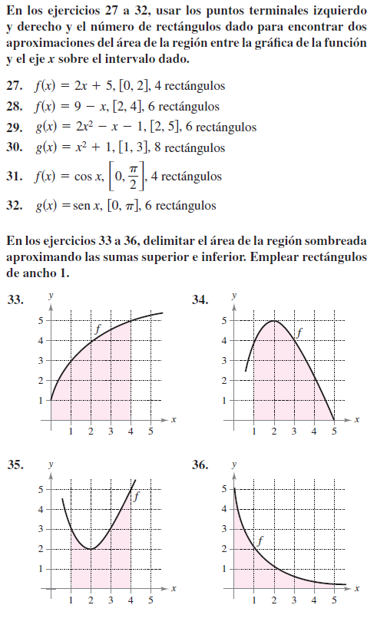 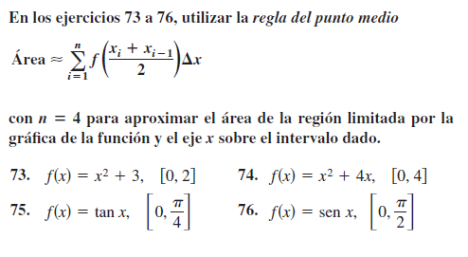 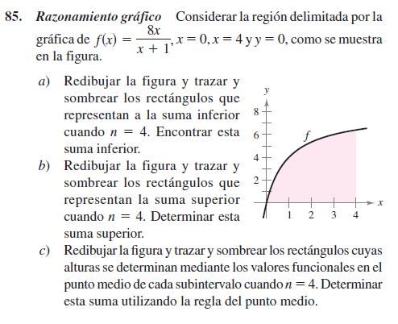 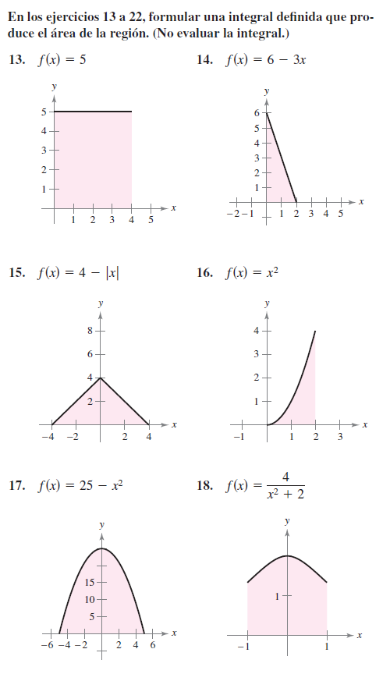 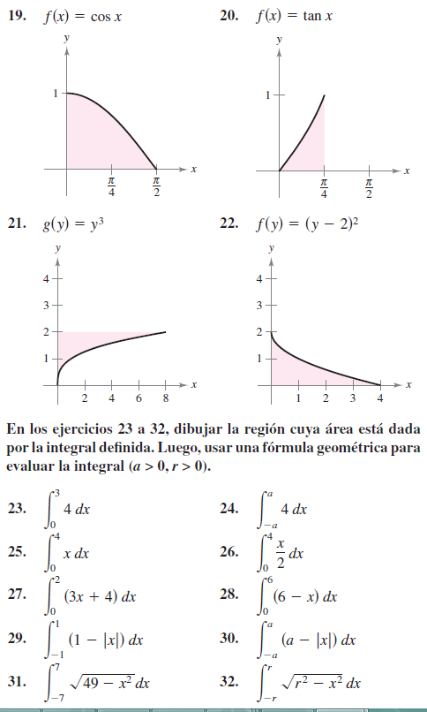 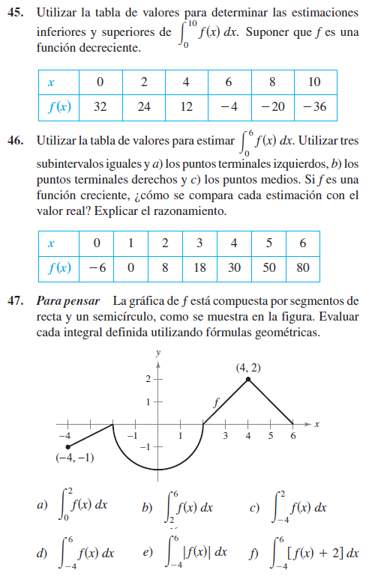 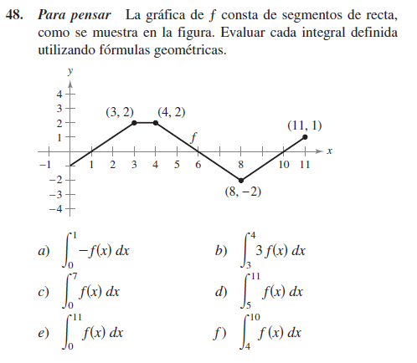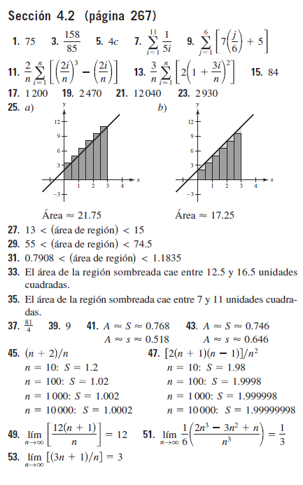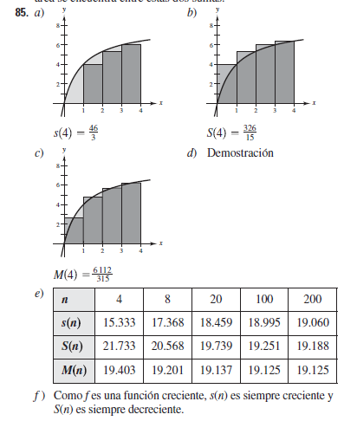

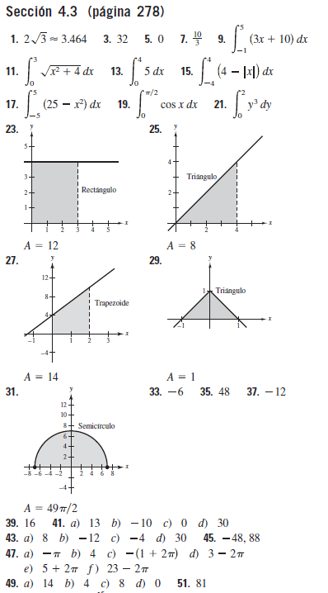

|  |  |  |  |  |  |  |
| --- | --- | --- | --- | --- | --- | --- |
| 0 | 2 | 2 | 2 | 2 | 2 |  |
| 32 | 24 | 12 | -4 | -20 | -36 |  |
| 0 | 48 | 24 | -8 | -40 | -72 | -48 |
|  |  |  |  |  |  |  |
|  |  |  |  |  |  |  |
| 2 | 2 | 2 | 2 | 2 | 0 |  |
| 32 | 24 | 12 | -4 | -20 | -36 |  |
| 64 | 48 | 24 | -8 | -40 | 0 | 88 |